Table of Contents

1, Experiment Setting 1

2, Install and configure Samba and Quota 2

2.1, Confirm iptables and selinux and dns 2

2.2,The software required to install samba 2

3, Configure Kerberos 3

3.1, Sync time 5

3.2, Test Kerberos 5

3.3, Modify /etc/nsswitch.conf 5

4, Configure Samba 6

4.1 Join AD 7

4.2, Start smb and winbind and Set to start automatically boot 7

4.3, Check samba server in AD Server 8

5, Auto create directory 8

6，Configure Quota 10

6.1, Configure LVM 10

6.2, Format the logic volume 11

6.3, Setup auto mount and quota 11

7, Setup script in AD Server 13

# 1, Experiment Setting

Hostname: ad.alv.pub

System Version: Windows Server 2008 R2

IP: 192.168.105.22

Service : Active Directory、DNS

Comment: AD already Installed, DNS already Installed, they work normal.

Hostname：samba.alv.pub

System Version: RHEL6.4

IP: 192.168.105.18

Service: Samba

# 2, Install and configure Samba and Quota

## 2.1, Confirm iptables and selinux and dns

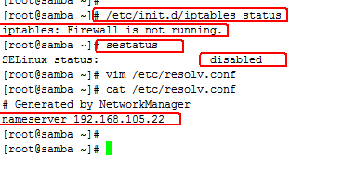

## 2.2,The software required to install samba

yum install krb5-workstation pam_krb5 krb5-devel krb5-libs samba4 krb5-auth-dialog samba4-swat samba4-common samba4-client samba4-winbind samba4-winbind-clients -y

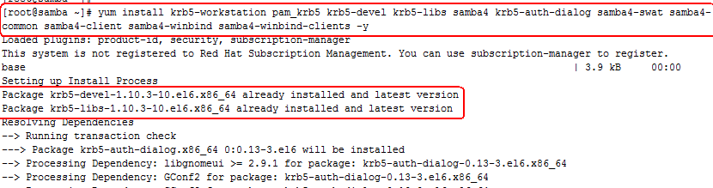

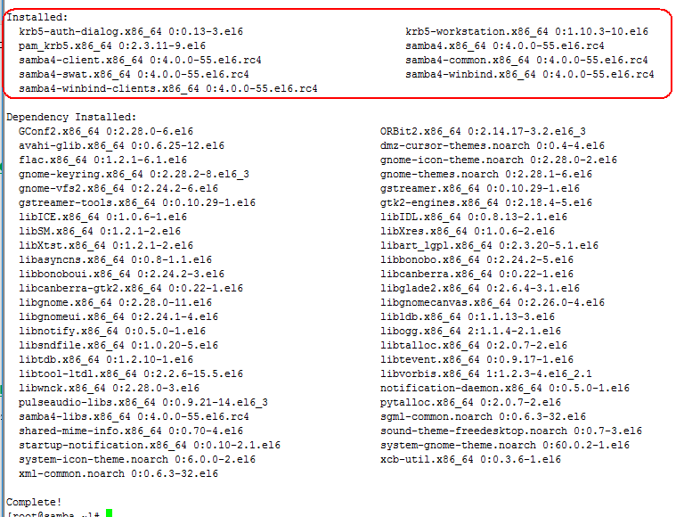

# 3, Configure Kerberos

[root@samba ~]# vim /etc/krb5.conf

[logging]

default = FILE:/var/log/krb5libs.log

kdc = FILE:/var/log/krb5kdc.log

admin_server = FILE:/var/log/kadmind.log

[libdefaults]

default_realm = ALV.PUB

dns_lookup_realm = false

dns_lookup_kdc = false

ticket_lifetime = 24h

renew_lifetime = 7d

forwardable = true

[realms]

ALV.PUB = {

kdc = 192.168.105.22

}

[domain_realm]

.alv.pub = ALV.PUB

alv.pub = ALV.PUB

[kdc]

profile = /var/kerberos/krb5kdc/kdc.conf

[appdefaults]

pam = {

debug = false

ticket_lifetime = 36000

renew_lifetime = 36000

forwardable = true

krb4_convert = false

}



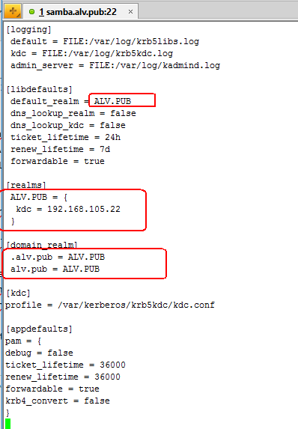

## 3.1, Sync time

[root@samba ~]# ntpdate 192.168.105.22



## 3.2, Test Kerberos

[root@samba ~]# kinit administrator@ALV.PUB

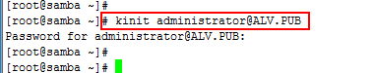

## 3.3, Modify /etc/nsswitch.conf

[root@samba ~]# vim /etc/nsswitch.conf

#group: db files nisplus nis

passwd: files winbind

shadow: files winbind

group: files winbind



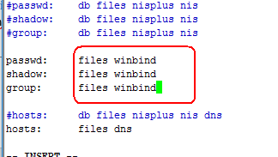

# 4, Configure Samba

[root@samba ~]# vim /etc/samba/smb.conf

[global]

workgroup = ALV

server string = Fileserv

password server = 192.168.105.22

realm = ALV.PUB

security = ads

idmap uid = 16777216-33554431

idmap gid = 16777216-33554431

template shell = /sbin/nologin

template homedir = /home/%U

winbind use default domain = true

winbind offline logon = true

winbind enum groups = yes

winbind enum users = yes



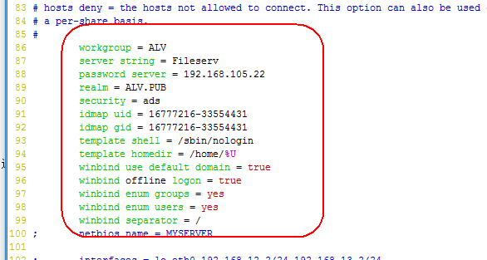

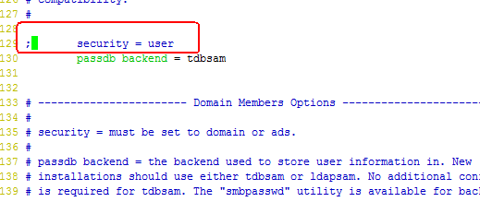

## 4.1 Join AD

[root@samba ~]# net ads join -U administrator@alv.pub

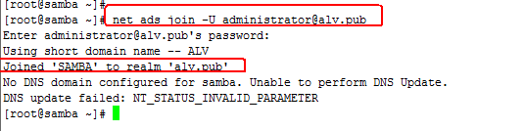

## 4.2, Start smb and winbind and Set to start automatically boot

[root@samba ~]# /etc/init.d/smb start

Starting SMB services: [ OK ]

[root@samba ~]#

[root@samba ~]# /etc/init.d/winbind start

Starting Winbind services: [ OK ]

[root@samba ~]#

[root@samba ~]# wbinfo -u

*

*

[root@samba ~]# chkconfig smb on

[root@samba ~]# chkconfig winbind on

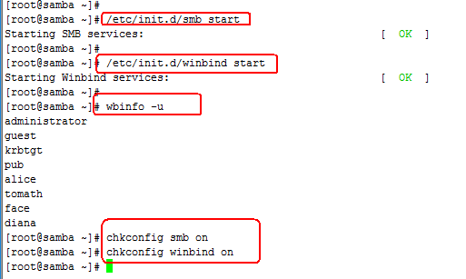

## 4.3, Check samba server in AD Server

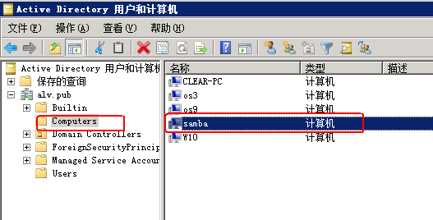

Yes, join successfully.

# 5, Auto create directory

Create a new file

[root@samba ~]# vim /etc/mkhome.sh

#!/bin/bash

user=$1

group=$2

home=/home/$1

if [ ! -d $home ] ; then

mkdir -p $home

chown $user $home

chgrp $group $home

chmod 700 $home

edquota -p administrator -u $user

fi



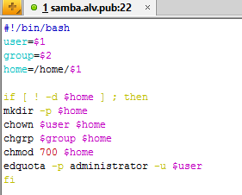

[root@samba ~]# chmod 700 /etc/mkhome.sh



[root@samba ~]# vim /etc/samba/smb.conf

[homes]

comment = Home Directories

path = /home/%U

valid users = alv.pub/%U

read only = no

browseable = no

writable = yes

root preexec = /etc/mkhome.sh %U %G



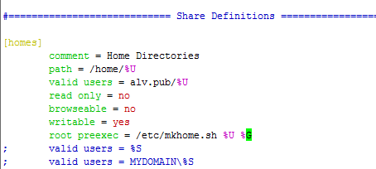

# 6，Configure Quota

## 6.1, Configure LVM

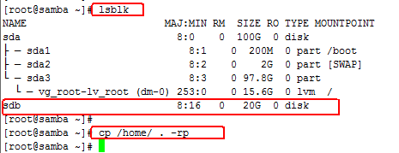

[root@samba ~]# pvcreate /dev/sdb

Physical volume "/dev/sdb" successfully created

[root@samba ~]# vgcreate vg_home /dev/sdb

Volume group "vg_home" successfully created

[root@samba ~]# lvcreate -L 18G -n /dev/vg_home/home_lv1 /dev/vg_home

Logical volume "ho_lv1" created

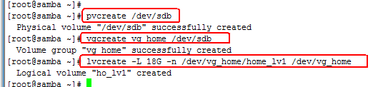

## 6.2, Format the logic volume

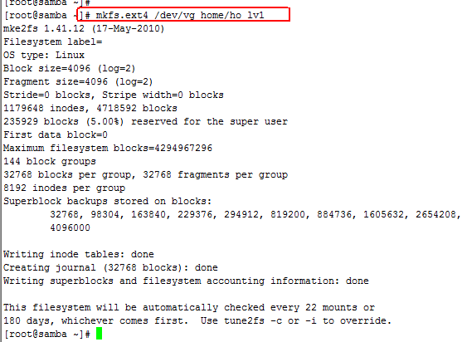

## 6.3, Setup auto mount and quota



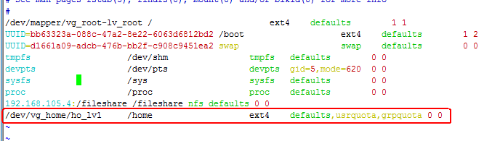

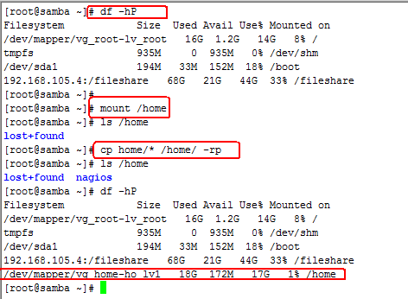

[root@samba ~]# quotacheck -guv /home/

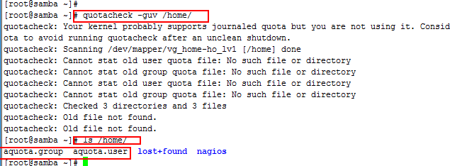

[root@samba ~]# quotaon -av

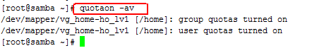

[root@samba ~]# edquota -u administrator



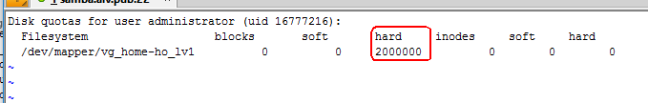

Tomath is my another AD user.



# 7, Setup script in AD Server

Script site: C:\Windows\SYSVOL\sysvol\alv.pub\scripts

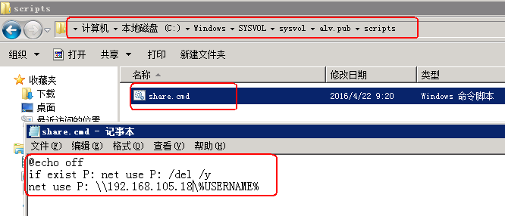

Script permission must be everyone can read.

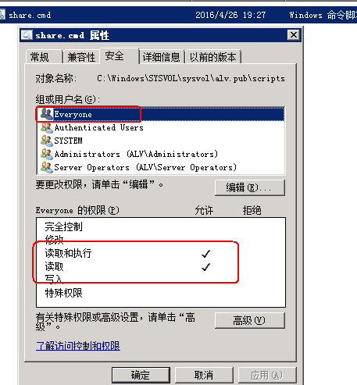

Setup user properties,

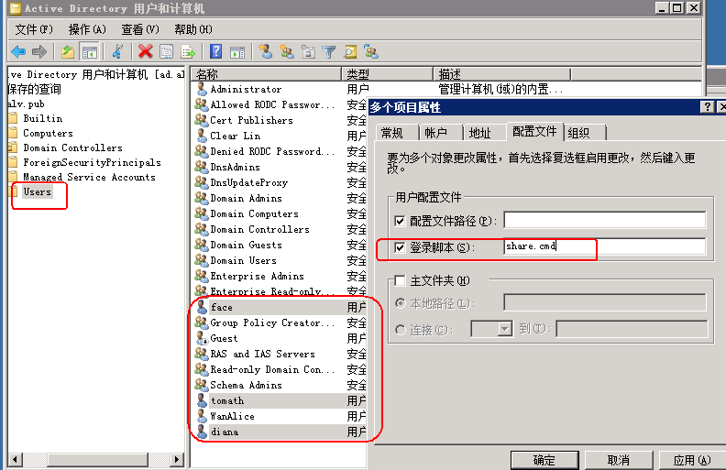

Let's take effect

Now, login AD user in AD clients will auto mount a disk.

